### **Indian Institute of Technology Kanpur**

**Department of Chemical Engineering**



**CHE331: Chemical Reaction Engineering**

### **Prof. Raj Ganesh S. Pala**

|  |  |
| --- | --- |
| Aadityaamlan Panda | 220007 |
| Adarsh Pal | 220054 |
| Akash Kumar Gupta | 220095 |
| Ansh Sethi | 220167 |

### 

**PHOTODEGRADATION OF METHYLENE BLUE USING H2O2 AS PROMOTER**

**Aim:** Study the chemical kinetics and determine the rate law for photodegradation of Methylene Blue using an Argon light / H2O2 irradiation system.

**Objective:** To analyze the order of the reaction by analyzing the R-squared data in three different scenarios performed varying the concentration of H2O2.

**Chemicals Required:** Distilled water, Methylene Blue (pure solid dye), H2O2 (aqueous) of known concentration, acetone and soap solution.

**Apparatus:** UV spectrometer, Photoreactor, Argon Light, Magnetic Stirrer, Test tubes, Volumetric Flasks, dropper, graduated cylinders.

**Hypothesis:** The complete photodegradation reaction is carried out 3 times at different concentrations of H2O2 keeping the initial concentration of Methylene blue solution same. The concentration vs time curve gives the dependence of rate law on concentration of Methylene blue. Changing the concentration of H2O2 gives the dependence of rate law on concentration of H2O2.

### **Theory:**

Methylene blue (MB) is a common industrial dye that poses environmental concerns when released into water bodies. Its persistence and toxicity make it a significant pollutant requiring effective removal methods.

Photodegradation studies of MB are crucial for developing efficient wastewater treatment technologies and understanding degradation mechanisms for organic pollutants in aqueous solutions.

Role of H₂O₂ and Light: H₂O₂ acts as an oxidizing agent, generating hydroxyl radicals (•OH) under light irradiation: H₂O₂ + hν → 2 •OH

Light serves two purposes:

1. Direct photolysis of MB molecules
2. Activation of H₂O₂ to produce reactive oxygen species

The degradation mechanism involves:

* Initial excitation of MB by light (MB → MB*)
* Generation of hydroxyl radicals from H₂O₂
* Attack of •OH radicals on MB structure
* Formation of degradation products through oxidation

Objectives:

* Establish efficient MB degradation using H₂O₂ and light
* Study reaction kinetics and optimize conditions
* Identify degradation products and pathways
* Develop practical applications for wastewater treatment

This process offers an environmentally friendly approach to treating dye-contaminated water while providing insights into photocatalytic degradation mechanisms.

### **Procedure**

1. The glassware was washed with tap water, followed by double-distilled water, and then kept in an oven at 90°C for 5 minutes to dry.
2. A stock solution of MB (10 ppm) was prepared. Precisely 10 mg of MB was added to 1 L of distilled water.
3. The solution was stirred for 10 minutes, and the flask was covered with aluminum foil to protect it from light.
4. Seven centrifuge tubes were washed with tap water, followed by double-distilled water, then kept in an oven at 90°C for 5 minutes to dry.
5. The **MB** solution was mixed with water and poured into the centrifuges in the ratio of **10:0**, **8:2**, **6:4**, **4:6**, **2:8**, **1:9**, **and 1:19** to prepare a 10 ml solution.
6. This solution was calibrated using a spectrophotometer to generate absorbance versus wavelength data at different concentrations. The peak absorbance was calibrated with the concentration to serve as a reference for plotting the rest of data.
7. To prepare the H₂O₂ solution: A standard solution of H₂O₂ was made by adding 15 mL of H₂O₂ to distilled water to reach a total volume of 50 mL, resulting in a 30% H₂O₂ solution.
8. The solution was covered with aluminum foil to avoid direct contact with light.
9. This H₂O₂ solution was added to the MB solution for the degradation experiment in the ratio of **27:273 v/v** to prepare a 300 ml solution. In the next iteration, this ratio was changed to **1:29**, the following iteration didn’t include the **H2O2**.
10. The samples from the photocatalytic reactor were collected at the end of every minute and analyzed in the spectrophotometer. Peak wavelength was used to calculate concentration using calibrated data.

### **Note:** For the detailed procedure, please click on this link [**ChE_331_Experimental_Video**](https://youtube.com/watch?v=NDle3TmiLoA&feature=shared)

### 

### **Equipment Description**

**Photocatalytic Reactor**

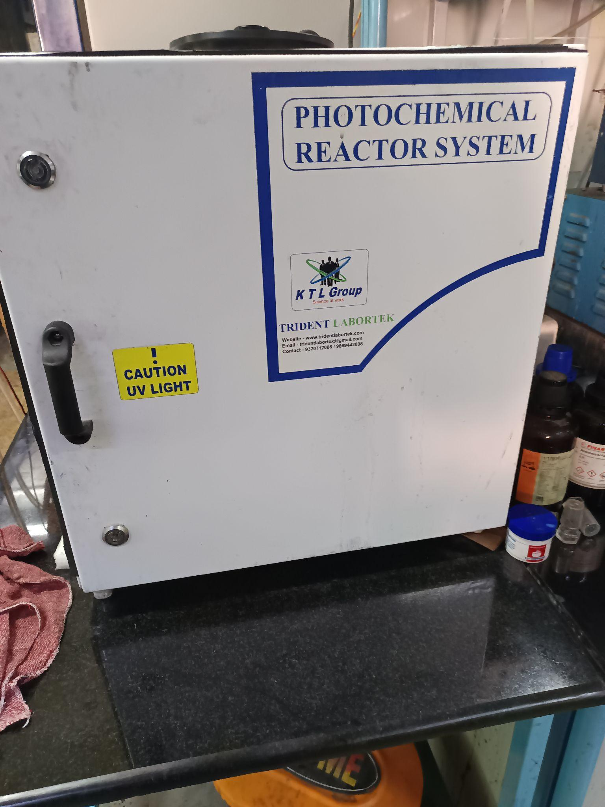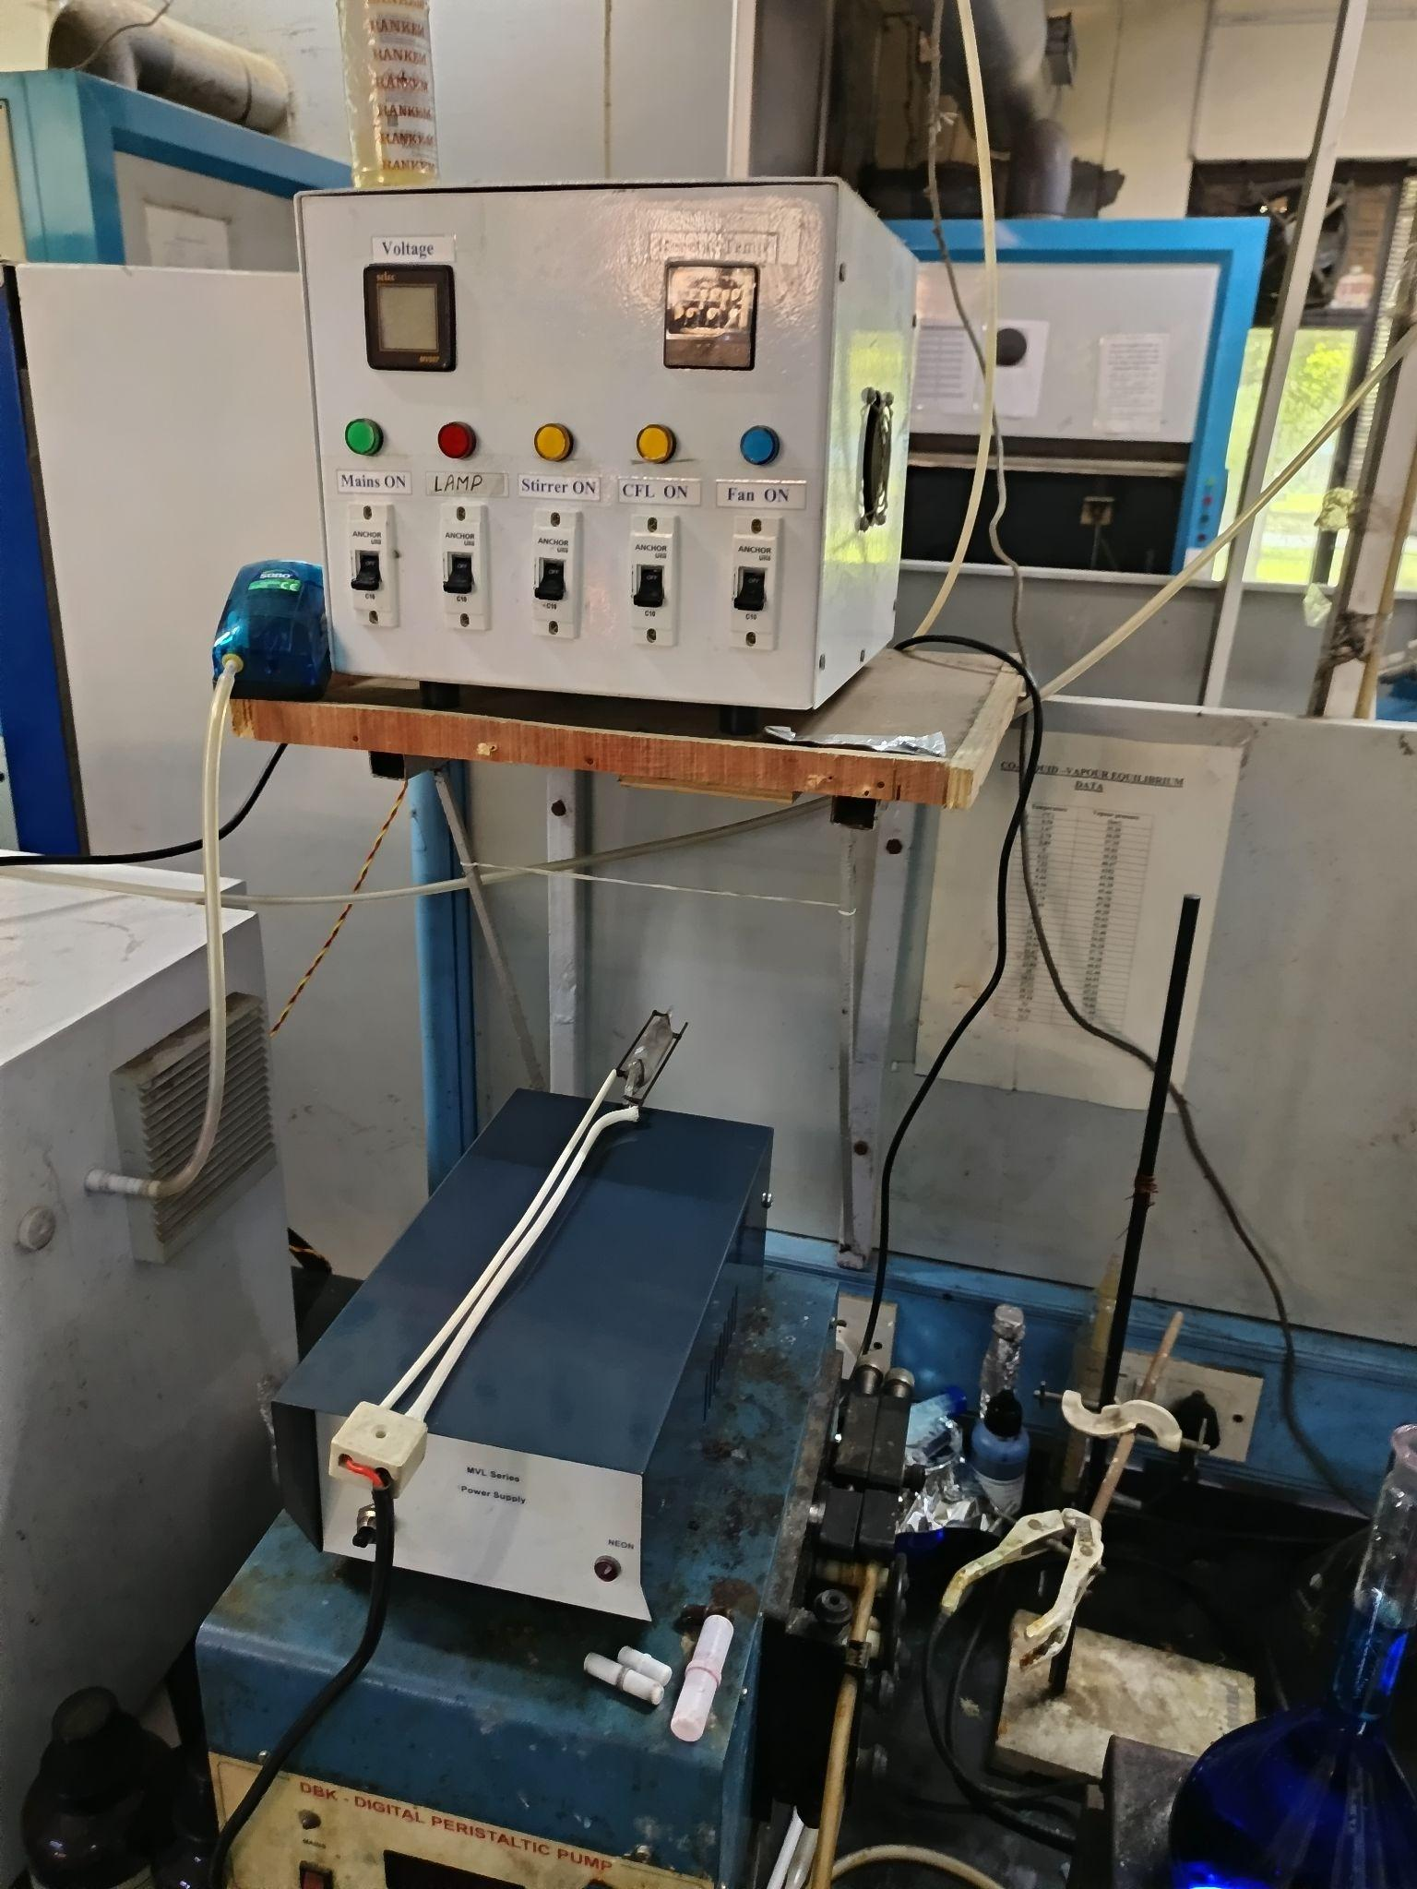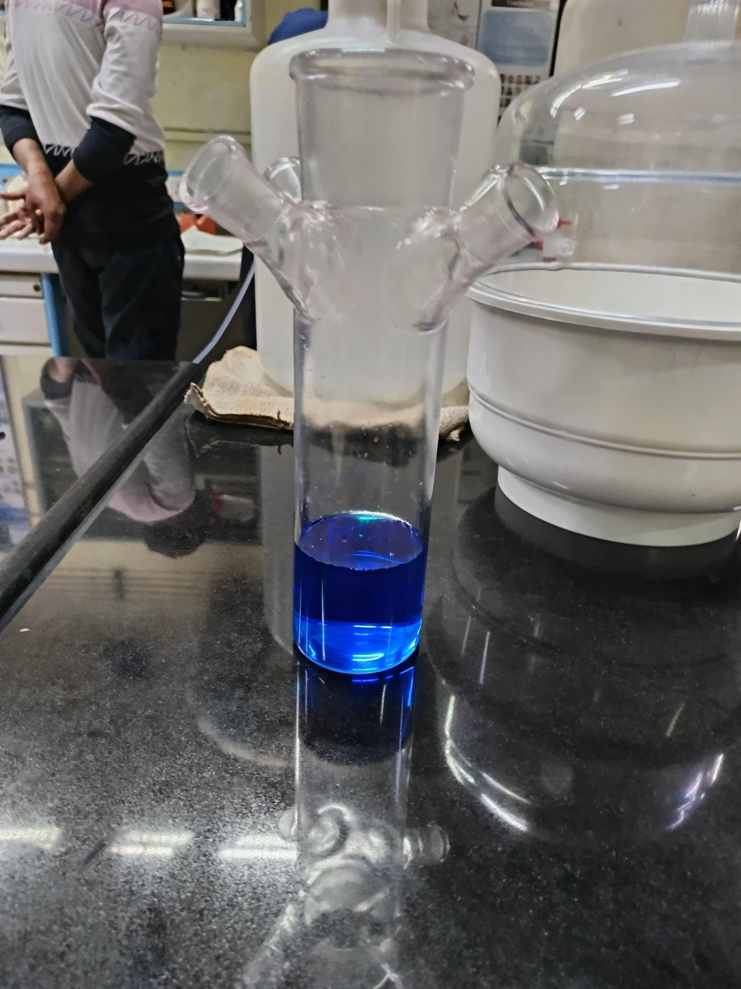

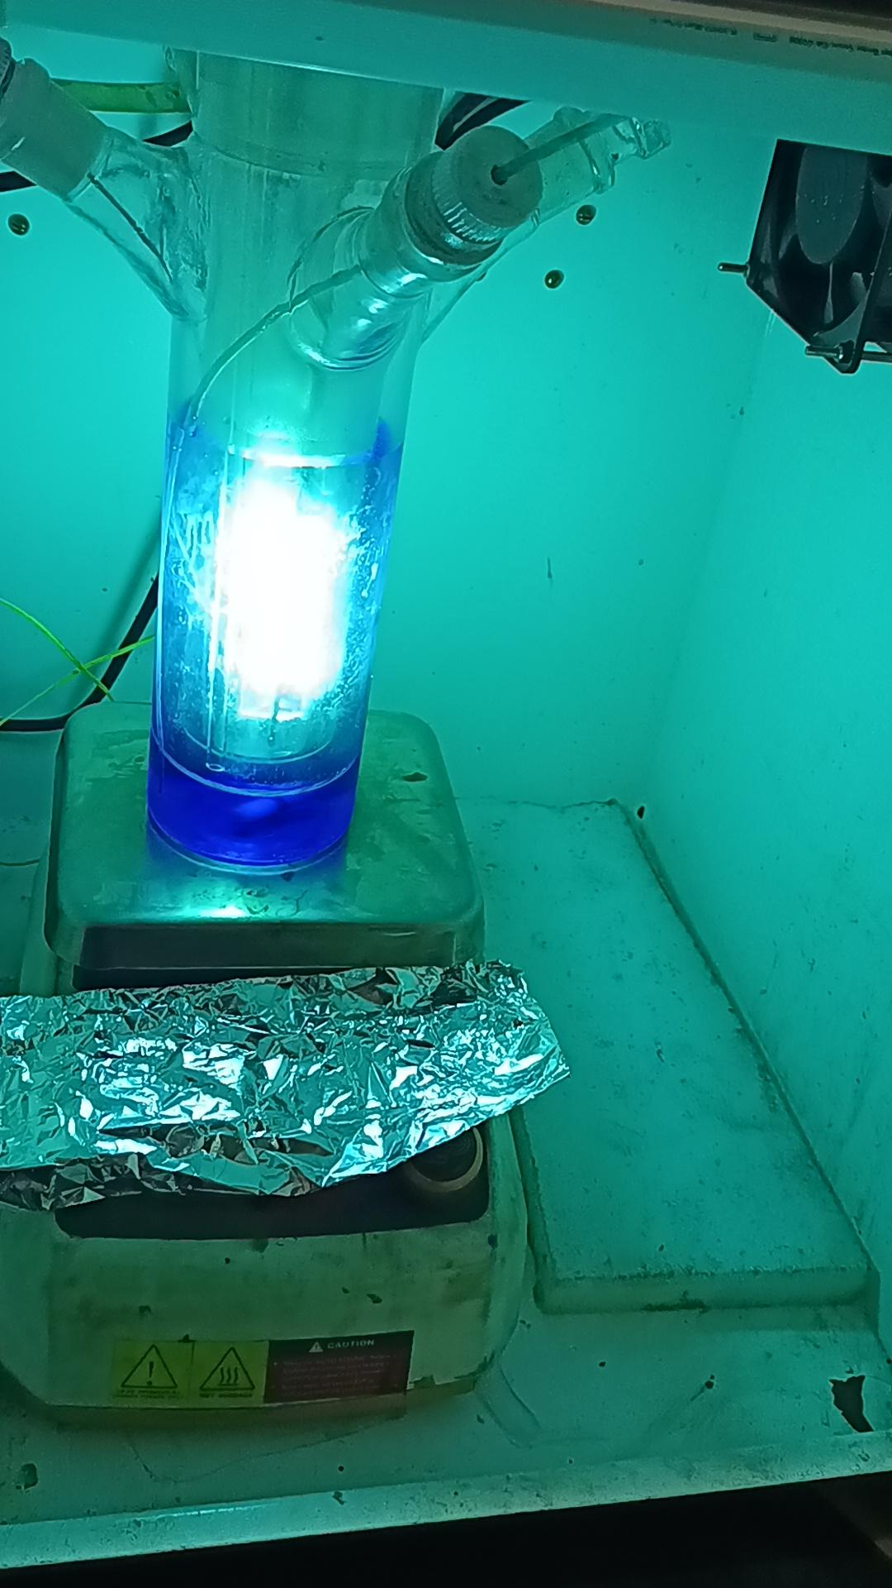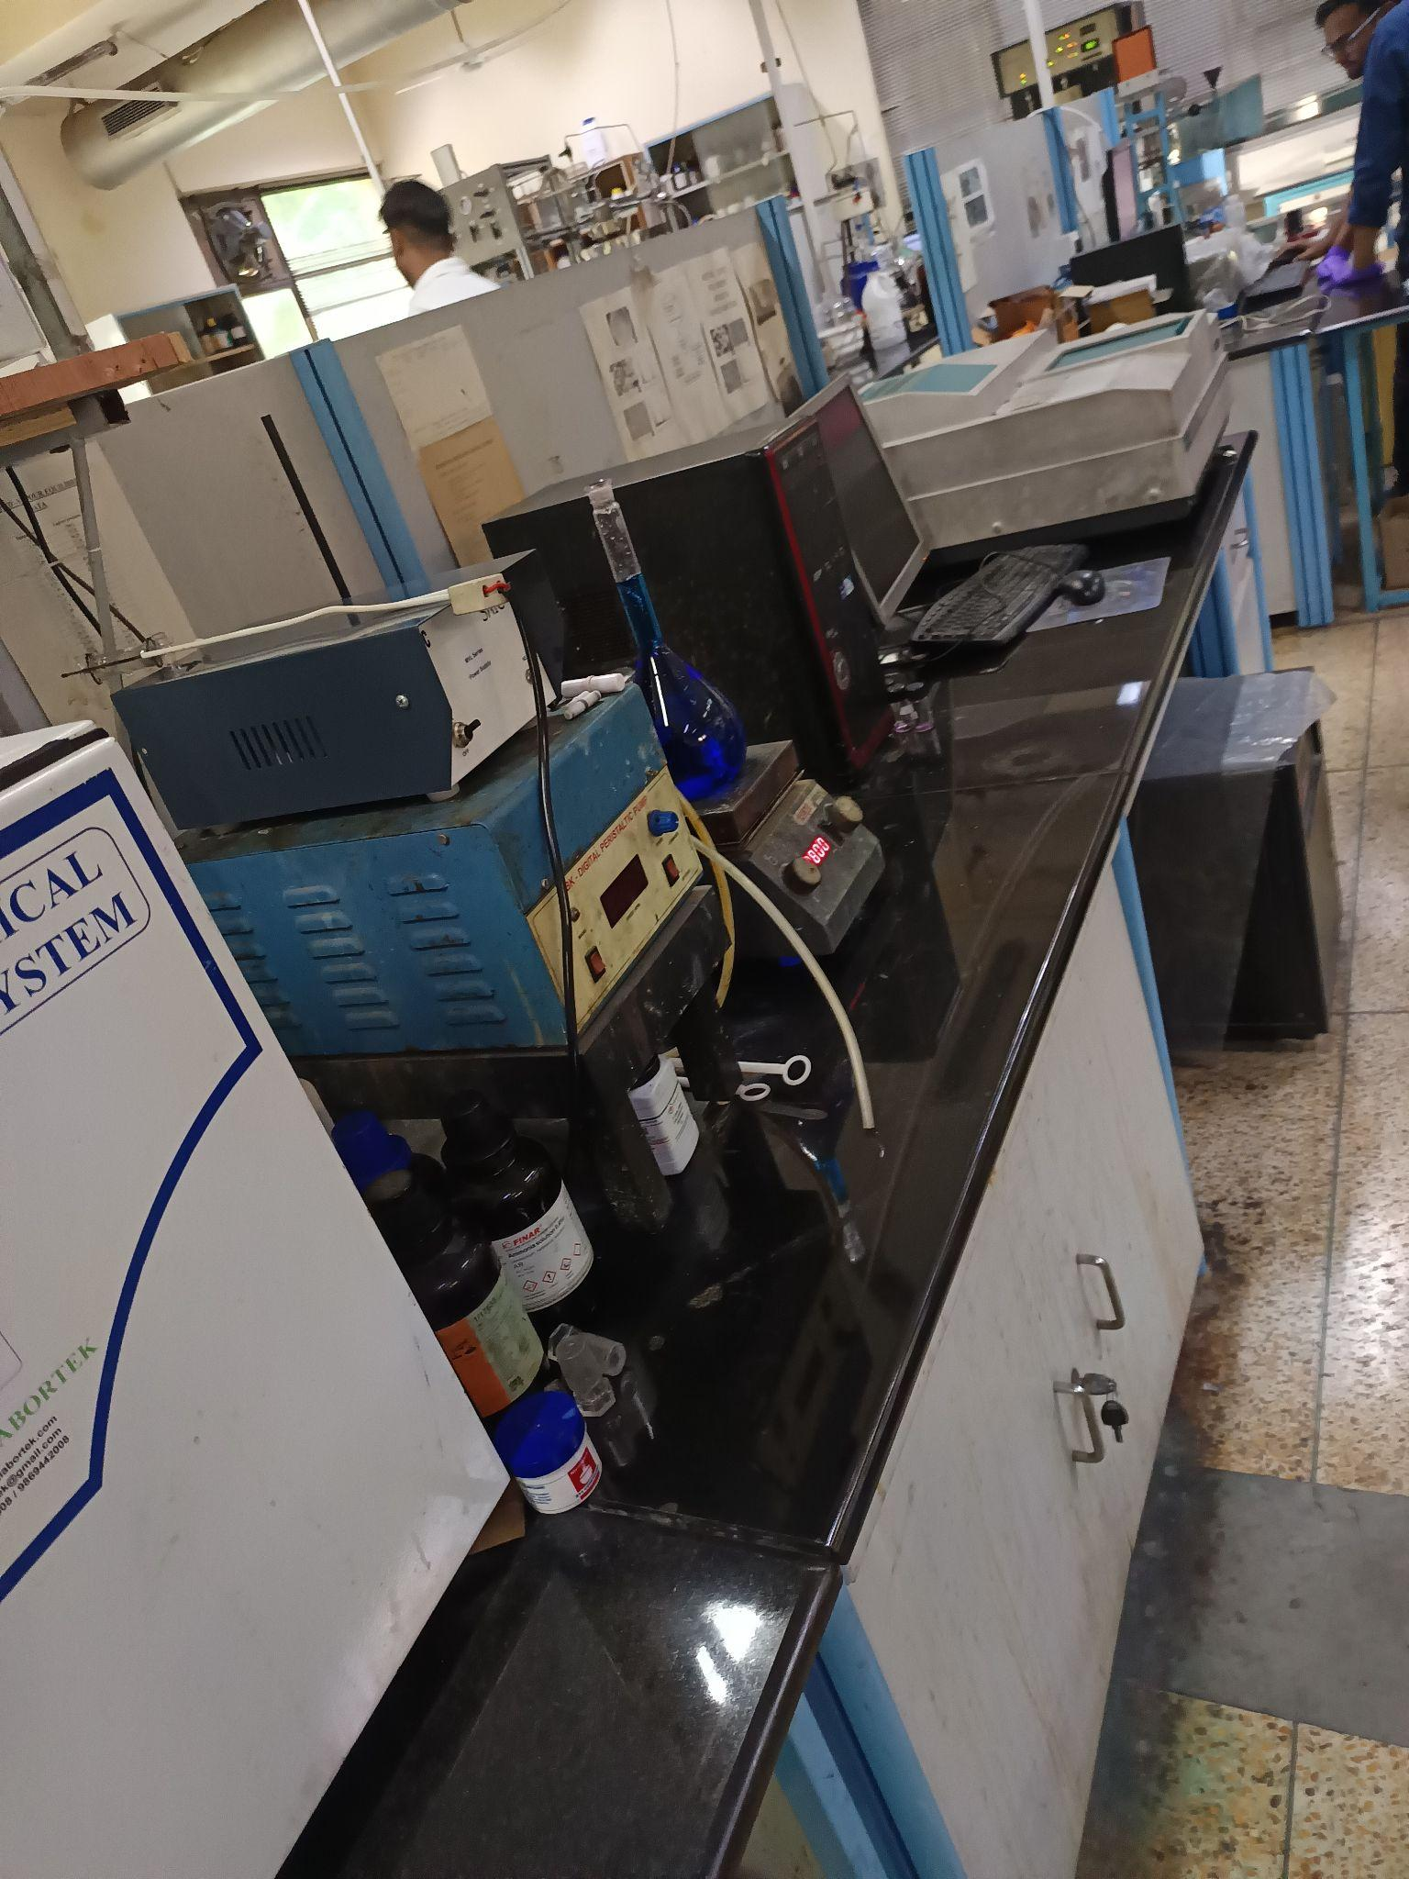

A photocatalytic reactor is a device used to carry out photocatalysis, a process where light energy (usually UV or visible) activates a catalyst to drive chemical reactions. It is commonly used for applications such as pollutant degradation, water purification, and hydrogen production.

A typical photocatalytic reactor includes:

- **Light Source**: UV or visible lamps to provide the required photons.

- **Catalyst**: Often a semiconductor like TiO₂, usually in powder form or on a substrate.

- **Reaction Chamber**: An enclosed area where the reaction takes place.

- **Gas/Liquid Flow System**: Ensures reactants and products are circulated and collected.

- **Temperature Control**: Maintains optimal conditions for the reaction.

**Spectroscopy**

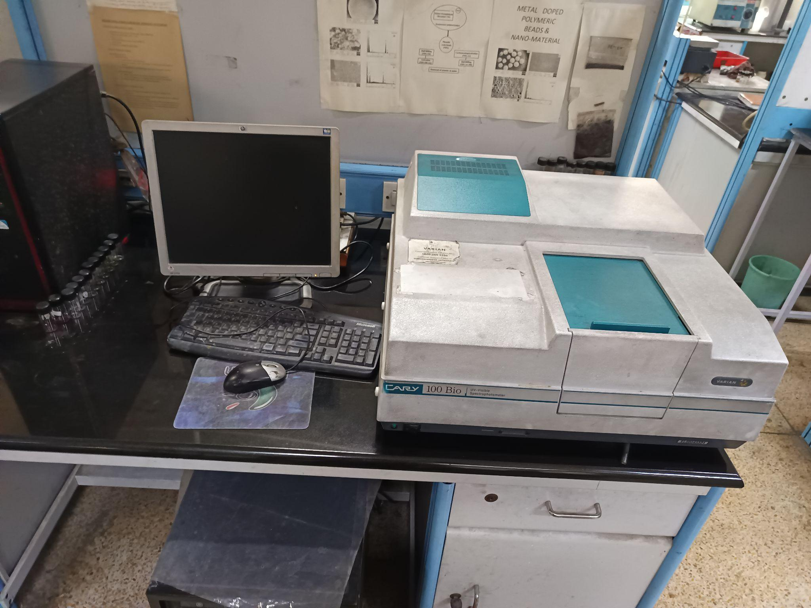

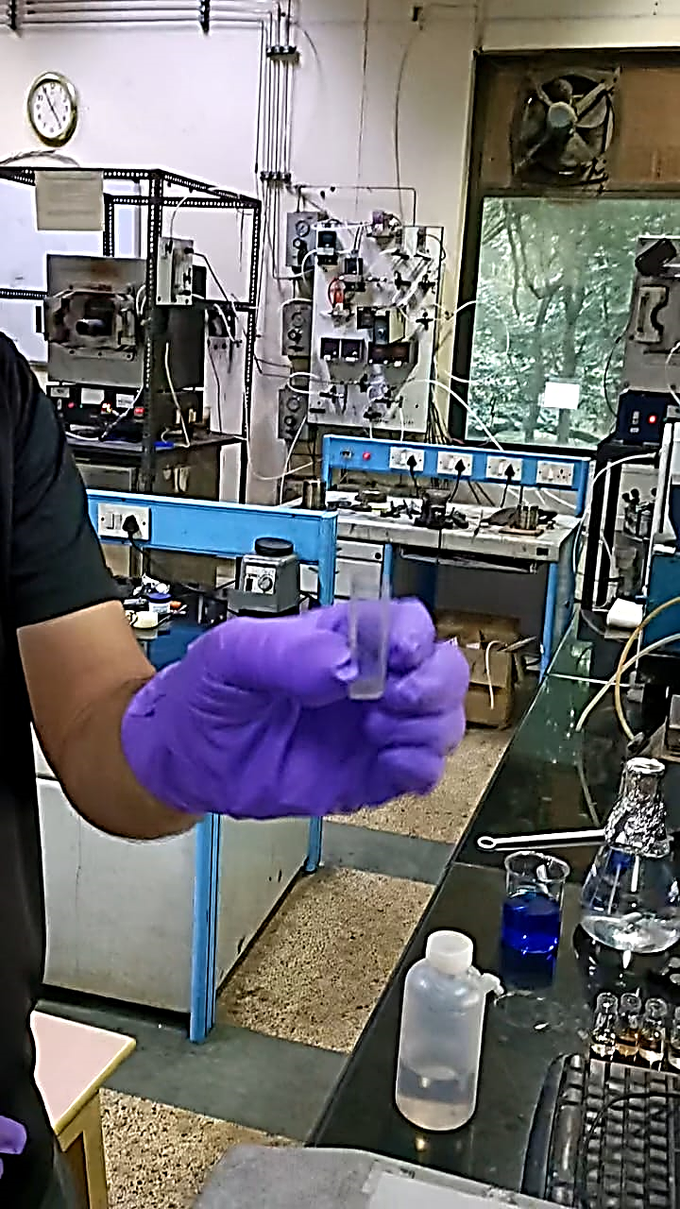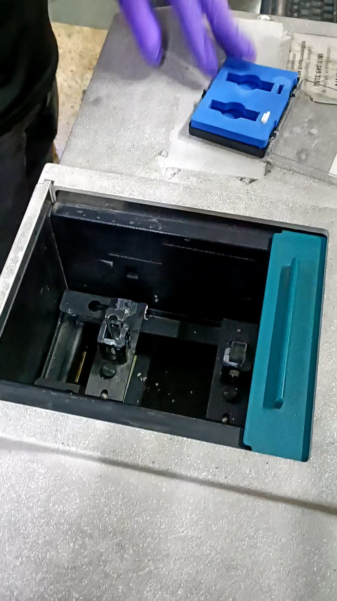

Spectroscopy is an analytical technique that studies the interaction between matter and electromagnetic radiation. It helps determine the composition, structure, and properties of substances by analyzing the spectrum produced when a material absorbs or emits light.

Common components of a spectroscopic setup include:

- **Light Source**: Provides radiation across a range of wavelengths.

- **Monochromator**: Isolates specific wavelengths for detailed analysis.

- **Sample Holder**: Holds the material being analyzed.

- **Detector**: Captures the radiation transmitted, absorbed, or emitted by the sample.

- **Data System**: Processes and displays spectral data.

- **Cuvette**: It has transparent and translucent sides on either faces and is used to hold the liquid being analyzed, with the transparent side facing the light source.

### **Observation**

### Initially, a 10 MB:1H₂O₂ solution was tested, and a sample was collected after 10 minutes. This attempt failed as the reaction went to completion due to the photocatalytic effect, indicating rapid degradation of MB. Next, a 29 MB:1 H₂O₂ solution was taken, and we observed the color changing rapidly between 0-1 minutes. The image below illustrates the changing concentration over time. Finally, the 10 MB:1 H₂O₂ solution was tested again, with concentration measurements taken every minute. Sample images at each minute are provided below to demonstrate the degradation process.

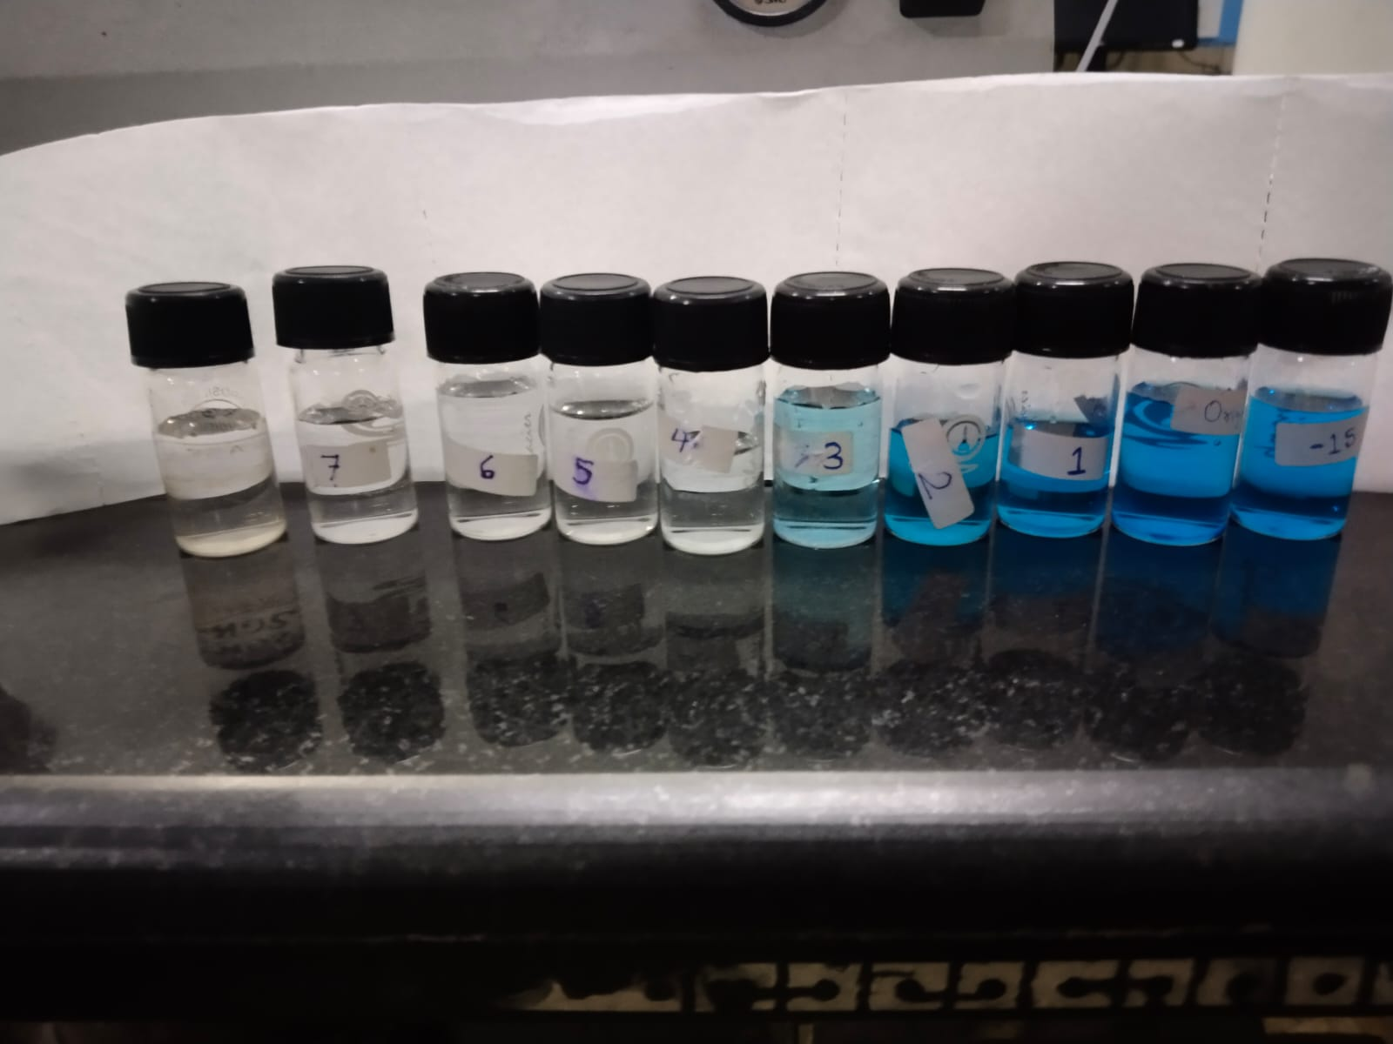

**10 ppm MB solution (290 mL) and 10 mL 30% H2O2**

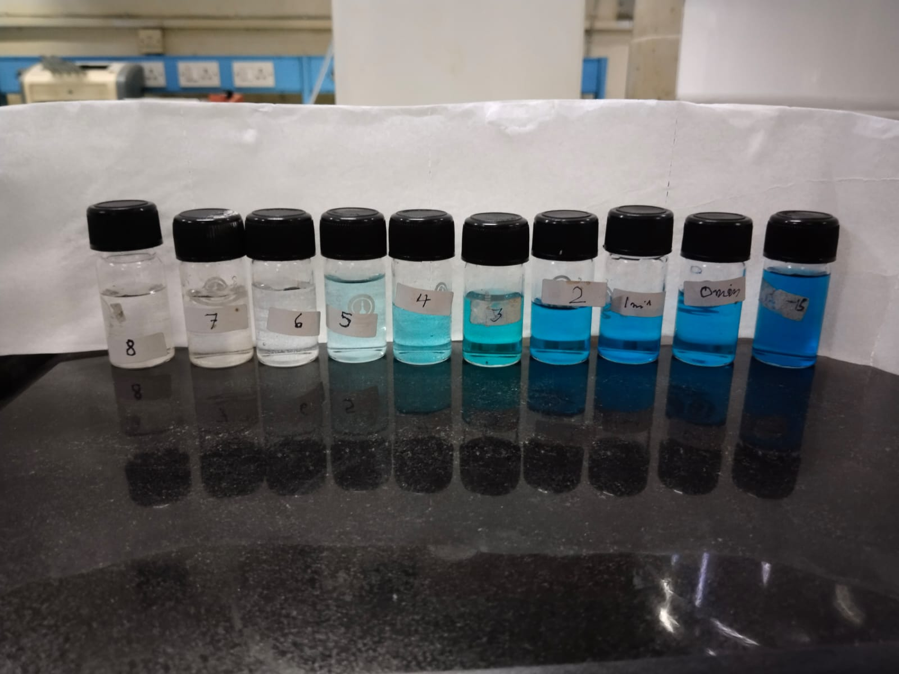

**10 ppm MB solution (273 mL) and 27 mL 30% H2O2**

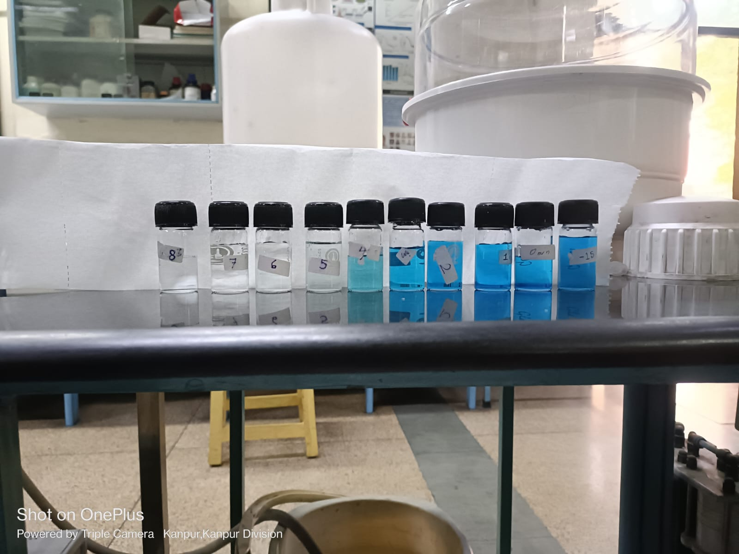

**10 ppm MB solution (300 mL) without H2O2**

### **Calculation and Plots**

**29 MB solution:1 H2O2 solution**

‘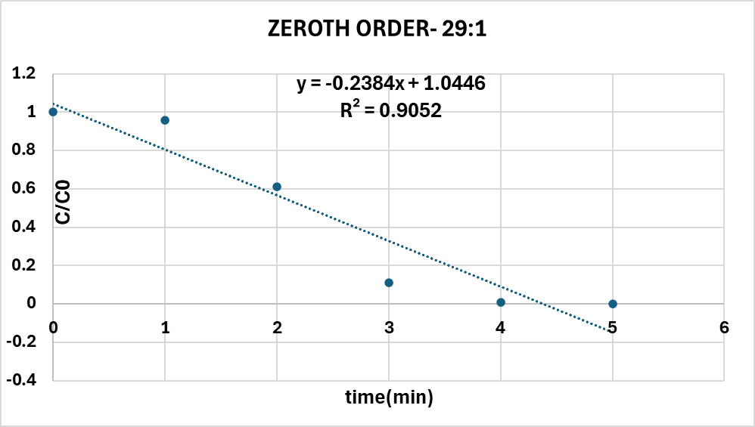

**Fig.1**

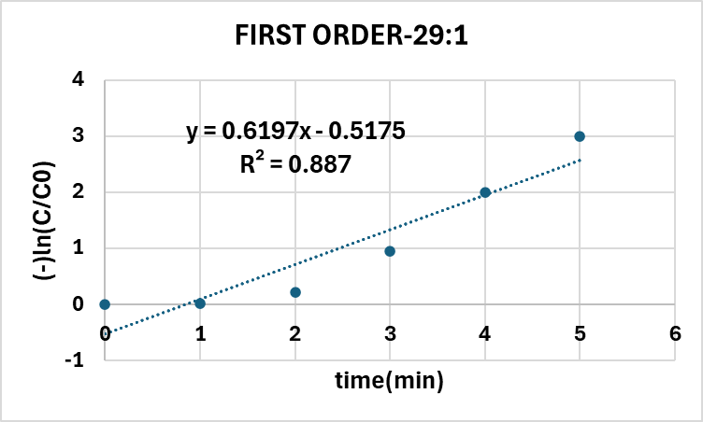

**Fig.2**

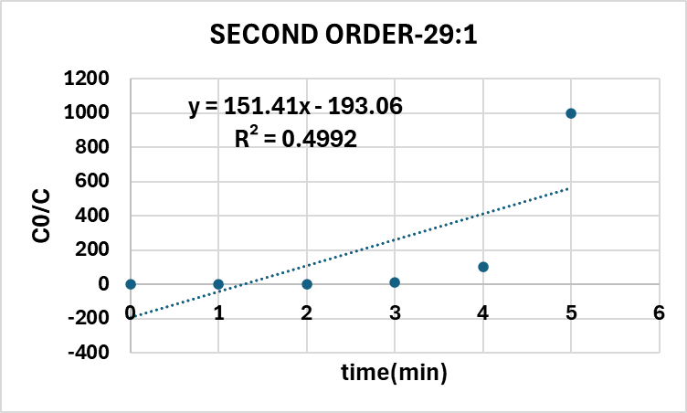

**Fig.3**

**10 MB solution:1 H2O2 solution**

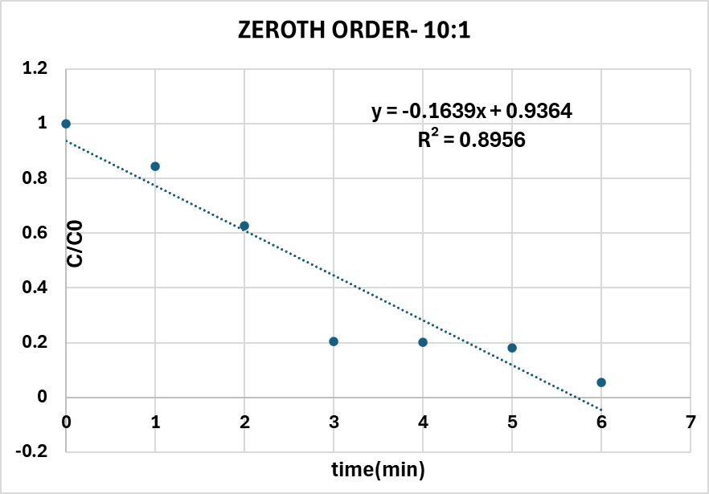

**Fig.4**

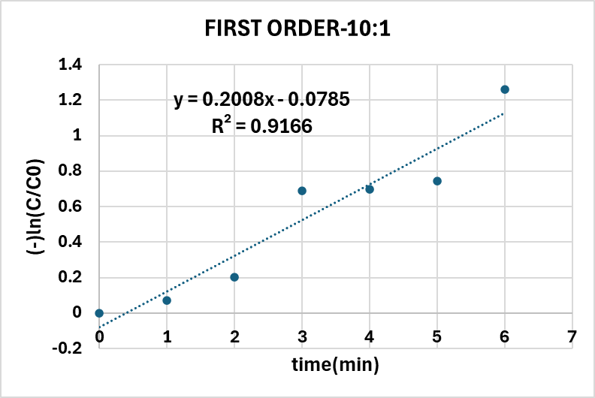

**Fig.5**

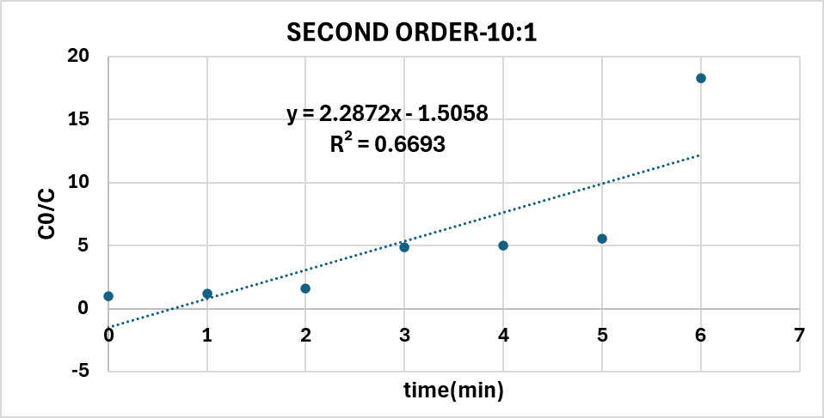

**Fig.6**

**10 PPM MB solution without H2O2**

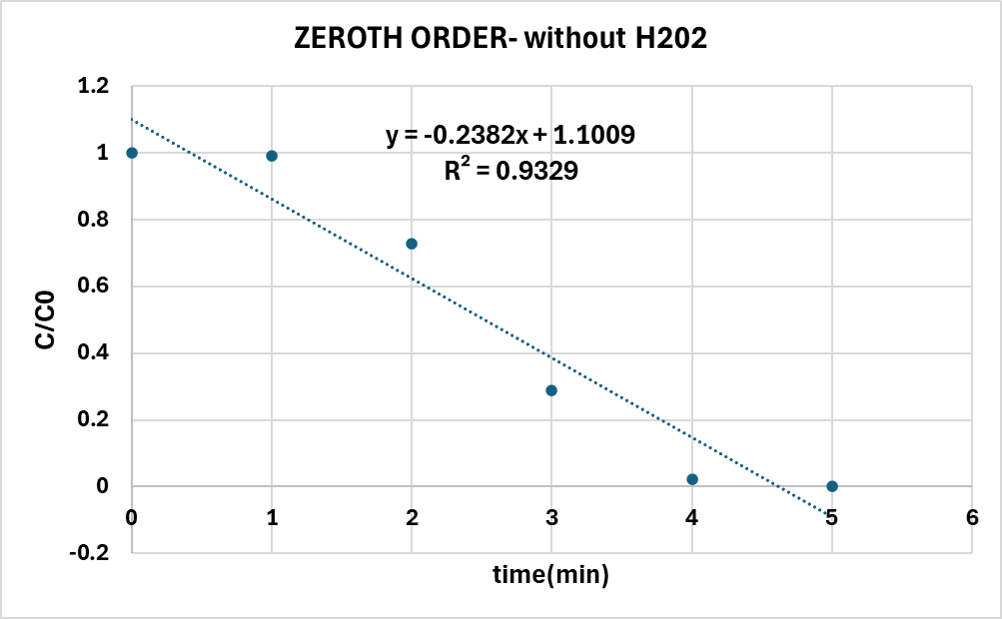

**Fig.7**

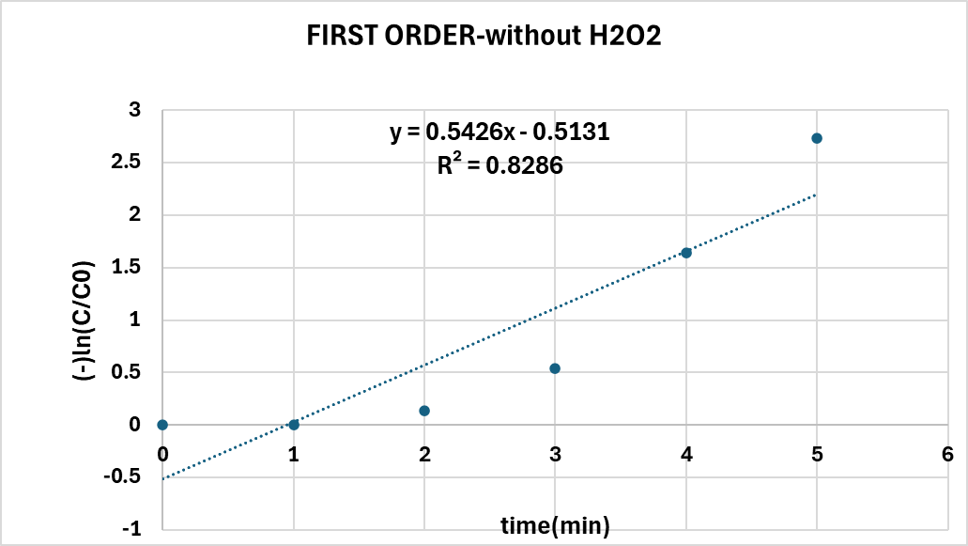

**Fig.8**

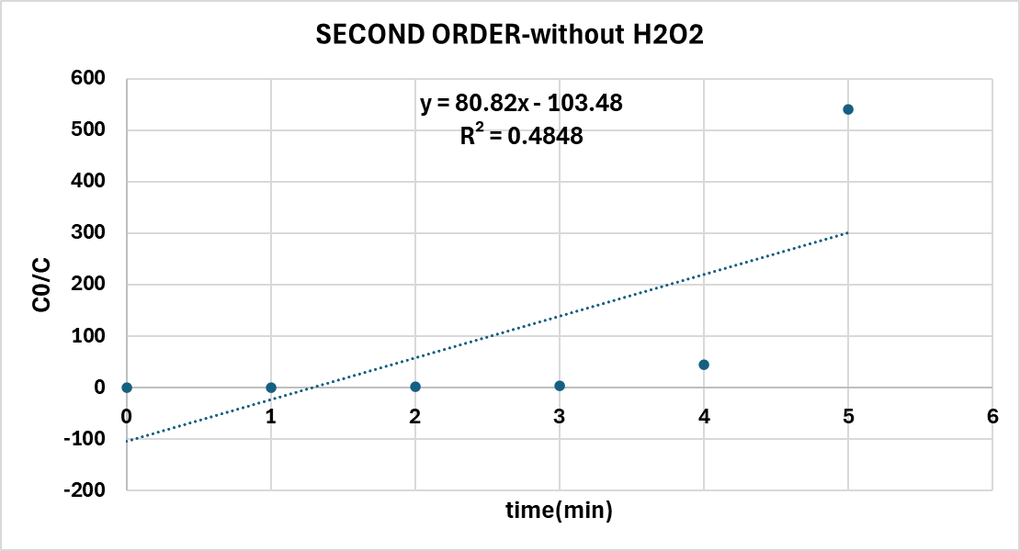

**Fig.9**

The following equations were used to calculate the value of k from the equation corresponding to the graph with best fit. The charts have been plotted based on the order of the following equations.

**Zeroth Order: $\frac{C_{A}}{C_{A0}}$**   *= 1- $\frac{kt}{C_{A0}}$*

**First Order: $ln(\frac{C_{A}}{C_{A0}})$** *= -kt*

**Second Order: $\frac{C_{A0}}{C_{A}}$** *= 1 + CA0kt*

### **Results**

|  |  |  |  |  |  |  |
| --- | --- | --- | --- | --- | --- | --- |
| **Process Conditions** | **Zeroth - Order Kinetics**  **(Ct/Co) vs time** | | **First - Order Kinetics**  **ln(Ct/Co) vs time** | | **Second - Order Kinetics**  **1/(Ct/Co) vs time** | |
|  | **R2** | **k(mol/(L min))** | **R2** | **k(min-1)** | **R2** | **k(L/(mol min))** |
| 10 ppm MB solution (273 mL) and 27 mL 30% H2O2 | 0.8956 | 1.40954 | 0.9166 | 0.2008 | 0.6693 | 0.265953 |
| 10 ppm MB solution (290 mL) and 10 mL 30% H2O2 | 0.9052 | 2.024471 | 0.887 | 0.6197 | 0.4992 | 17.82991 |
| 10 ppm MB solution (300 mL) without H2O2 | 0.9329 | 2.22717 | 0.8286 | 0.5426 | 0.4848 | 8.64385 |

According to R2 values, the given reaction follows the following order in different process conditions:

1. In the first solution, R2 is the maximum for a first-order reaction (high concentration of H2O2)
2. In the second solution, R2 is maximum for zero order reaction (low concentration of H2O2)
3. In the third solution, R2 is the maximum for a zero-order reaction

So, according to this trend, the order of reaction shifts from the first order to zero order when the concentration of H2O2 decreases.

**Sources of error**

Measuring 10 mg methylene blue while preparing stock solution

Measuring H₂O₂ while preparing the different concentrations of H₂O₂ before each reaction.

Error in the fitting of the calibration curve using the calibration data from the UV spectrometer

Improper exposure of the reaction solution to light leads to uneven data. This occurs sometimes due to improper stirring of the reaction mixture.

### **Conclusions**

The photocatalytic degradation reaction of methylene blue in the presence of H2O2 was found to show different orders for different concentrations of H2O2. **When H2O2 concentration is increased, the reaction is found to change from zero to one**, as evident from the values of R2 for different kinds of parameters in case of zeroth, first and second order reactions, that varied linearly with time. The reaction even progressed in the **absence of peroxide** with light only, where it behaved like a **zeroth order reaction.**

### **Applications**

1. The study highlights how varying H₂O₂ concentrations influence the photocatalytic degradation of methylene blue (MB). This understanding aids in optimizing dye removal in wastewater treatment.
2. The reaction's ability to progress without H₂O₂ under light suggests potential for peroxide-free photocatalytic systems, reducing chemical usage and environmental impact.
3. Knowledge of reaction order changes allows for the design of flexible treatment systems tailored to different H₂O₂ concentrations.

### **Contributions**

Research Work: All members

Experimental work: All members

Experimental set-up: Akash Kumar Gupta, Aadityaamlan Panda and Adarsh Pal

Plots and curve-fitting: Ansh Sethi, Aadityaamlan Panda and Adarsh Pal

Calculations: Akash Kumar Gupta, Ansh Sethi and Aadityaamlan Panda

Report: All members

Result and observations: Akash Kumar Gupta, Adarsh Pal and Ansh Sethi

Video Filming and Editing: All members

### **Signatures:**

|  |  |
| --- | --- |
| **Names** | **Signature** |
| Aadityaamlan Panda |  |
| Adarsh Pal |  |
| Akash Kumar Gupta |  |
| Ansh Sethi |  |